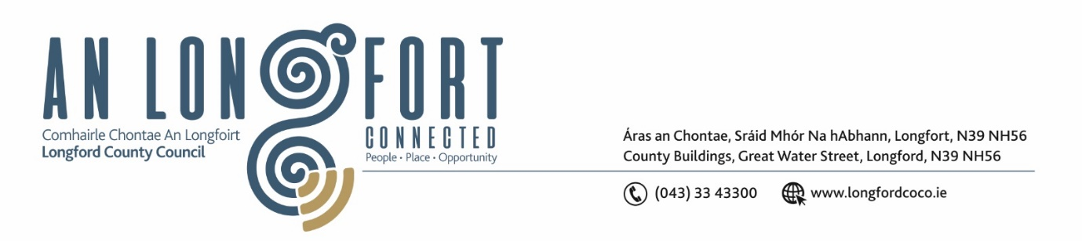

***Please note meeting will be held via Microsoft Teams.***

2 Nollaig 2021.

**Chuig: Gach Ball don Chomhairle.**

A Chomhairleoir,

Iarrtar ort bheith i láthair ag Cruinniú Míosuil Chomhairle Chontae Longfoirt a tionólfar via MS Teams are an **Chéadaoin, 8 Nollaig 2021 ag** **3pm** chun gnó a dhéanamh d’réir an Chláir thíos.

You are requested to attend the Monthly Meeting of Longford County Council to be held **via Microsoft Teams** on **Wednesday, 8 December 2021 at 3pm** to transact business, as set out on the Agenda hereunder.

Mise le meas,

*Ann Marie Mc Keon*

**__________________**

**Ann Marie Mc Keon**

**Meetings Administrator.**

**C L Á R**

Prayer before meeting.

1. Confirmation of Minutes
2. Monthly Meeting of Longford County Council held on 10 November 2021 –

copy enclosed.

(ii) Minutes of Committee Meeting of Longford County Council held on 19

October 2021 – copy enclosed.

(iii) Minutes of Meeting of Longford County Council held on 19

October 2021 – copy enclosed.

(iv) Minutes of Finance Meeting of Longford County Council held on 15November 2021 – copy enclosed.

1. Minutes of Budget Meeting of Longford County Council held on 22

November 2021 – copy enclosed.

1. Matters Arising.
2. Declaration of Interest by Members.
3. To note Management Report – to follow.

**5.** To note adopted Minutes of Corporate Policy Group Meeting held on the

12th October 2021 – enclosed.

**6. Community, Corporate and Enterprise**

**(a)** Chief Executive Annual Progress Report on Implementation of the Corporate Plan -

Enclosed.

**(b)**  (i) Political Donations - Local Elections (Disclosure of Donations

and Expenditure) Act 1999, as amended - Members of Local Authorities.

**(Departmental Guidelines and forms for completion will be circulated)**

(ii) Political Donations - Local Elections (Disclosure of Donation

and Expenditure) Act 1999, as amended - Third Parties.

**(Departmental Guidelines and forms for completion will be circulated)**

**(c)** Date of January 2022 County Council meeting.

**(d)** Delivery of Public Service Civic Centre in Longford Town.

**(e)** Consideration of Civic Reception - Farrell Clan.

**7. Strategic Infrastructure, Regeneration and Climate Change**

**(a)** To note Planning Applications received since last meeting of the Council.

**(b)** List of attendees – Transport Infrastructure Ireland (TII) Deputation.

**8. Finance**

**(a)** NOAC Local Authority Performance Indicator Report 2020 – enclosed.

**(b)** Consideration of the disposal of property at Esker South, Ballinalee, County Longford (under the shared ownership scheme), in accordance with the terms of Section 183 of the Local Government Act 2001 issued on the 22nd November 2021.

**(c)** Consideration of the disposal of property at 102 Gleann Riada, Strokestown Road, Longford (under the shared ownership scheme), in accordance with the terms of Section 183 of the Local Government Act 2001 issued on the 22nd November 2021.

**(d)** Over-view of circulars:

LG 04-21 Increase to Annual Remuneration of Elected Members - enclosed

LG 05-21 Allowances and Expenses of Elected Members – enclosed

LG 05-21 Appendix 1 Allowances and Expenses of Elected Members - enclosed

**9. Correspondence**

1. Correspondence dated 11 November 2021 received from the Minister of Health - Palliative Care Beds at St. Joseph's Care Centre, County Longford – enclosed.

(ii) Correspondence dated 26 November 2021 received from the Minister of Health –

Re Notice of Motion submitted by Councillor Garry Murtagh on Home Supports

– enclosed.

(iii) Correspondence dated 17 November 2021 received from ESB – Re Deputation

from Longford County Council – enclosed.

**10. Votes of Sympathy**